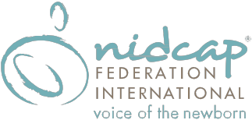

Registration Form – NFI One Day Conference
NIDCAP: Developmental Care of the NICU Infant and Family from Admission to Discharge

Click Here to Register Online and pay using PayPal or by check/money order, or complete this mail-in registration form and send it with payment to address below. Click tag icon for fillable version of form (Note: if you wish to use fillable version you may have to save file to computer before clicking “tag”.

PARTICIPANT INFORMATION

Last Name First Name Middle Initial

Degree(s) Discipline/Specialty

Institution/Employer Job Title

Street Address

City State Postal Code Work Phone

Home Address

City State Postal Code Home Phone

Email Address (required)

Dietary Requirements (if applicable):  ☐ Vegetarian  ☐ Vegan  ☐ Gluten- Free | Lactation Room Needs:  ☐ Check if lactation room needed
How did you hear about the conference?
☐ Email Notification ☐ NFI Website ☐ NFI Facebook ☐ NFI LinkedIn Page
☐ From a Friend/Colleague ☐ General Web Search ☐ Other :

PAYMENT INFORMATION
☐ Check or Money Order enclosed. (Make check payable to NIDCAP Federation International, Inc.)
Amount Paid: ☐$140 (Early Registration) ☐$150 (Regular Registration) ☐$160 (Late Registration)

Mail form and check/money order to:
NFI Conference Administration
NIDCAP Federation International
6300 Creedmoor Road, Suite 170-127
Raleigh, NC 27612

Questions?
Contact James Helm at nficonference@nidcap.org or 919.350.8276

www.nidcap.org Click Here to Register Online

