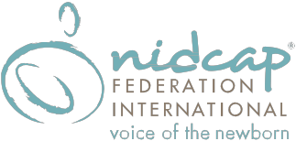
Registration Form

NFI One Day Conference | Oakland, CA – September 13, 2017
NIDCAP Care within Newborn Intensive Care Nurseries

Click Here to Register Online and pay using PayPal or by check/money order, or complete this mail-in registration form and send it with payment to address below.

PARTICIPANT INFORMATION

Last Name First Name Middle Initial

Degree(s) Discipline/Specialty

Institution/Employer Job Title

Street Address

City State Postal Code Work Phone

Home Address

City State Postal Code Home Phone

Email Address (required)

Dietary Requirements (if applicable):
☐ Vegetarian
☐ Vegan
☐ Gluten-Free

How did you hear about the conference?
☐ Email Notification ☐ NFI Website ☐ NFI Facebook ☐ NFI LinkedIn Page
☐ From a Friend/Colleague ☐ General Web Search ☐ Other :

PAYMENT INFORMATION
☐ Check or Money Order enclosed. (Make check payable to NIDCAP Federation International, Inc.)
Amount Paid:
☐$140 Early Registration (Before Aug 1) ☐$150 Regular Registration ☐$160 Late Registration (After Aug 31)

Mail form and check/money order to:
NFI Conference Administration
NIDCAP Federation International
6300 Creedmoor Road, Suite 170-127
Raleigh, NC 27612

Questions?
Contact James Helm at nficonference@nidcap.org or 919.350.8276

www.nidcap.org Click Here to Register Online

