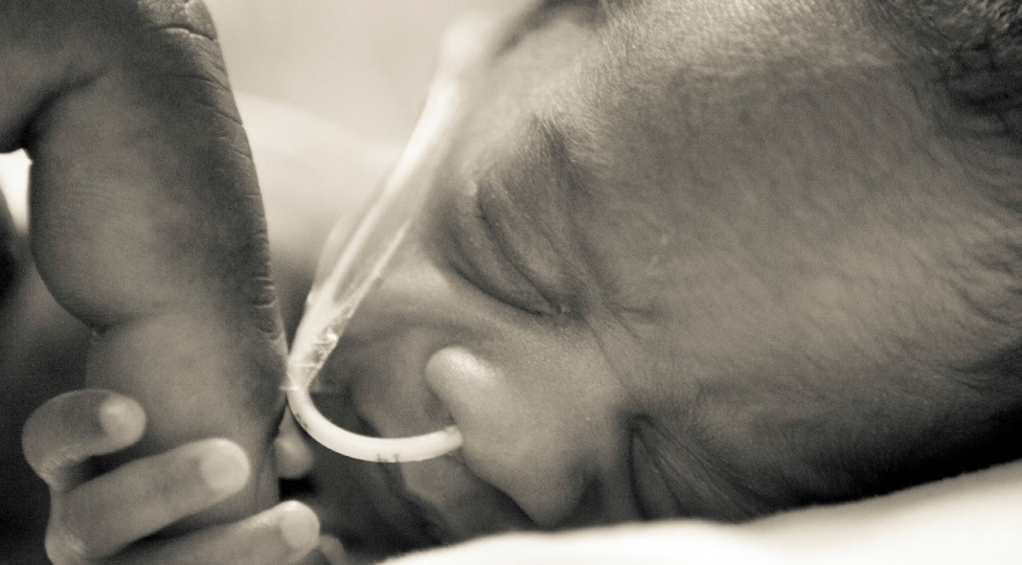

voice of the newborn
nidcap.org

Mentoring Caregivers. Changing Hospitals. Improving the Future for Newborns & Their Families.
A donation was made to the NIDCAP Federation International…

In honor of:

By:

…to support preterm and medically at risk newborns and their families around the world.

NFI Mission: The NFI promotes the advancement of the philosophy and science of NIDCAP care and assures the quality of NIDCAP education, training and certification for professionals and hospital systems.

NFI Vision: The NFI envisions a global society in which all hospitalized newborns and their families receive care in the evidence-based NIDCAP model. NIDCAP supports development, enhances strengths and minimizes stress for infants, family and staff who care for them. It is individualized and uses a relationship-based, family-integrated approach that yields measurable outcomes.

